T-BAT-CHARGER reports Battery Mismatch

Author: Eason
Reviewer:Steven
FAQ\ BAT
Issue introduction
T-BAT-CHARGER reported Battery Mismatch which led to the failure to recharge.
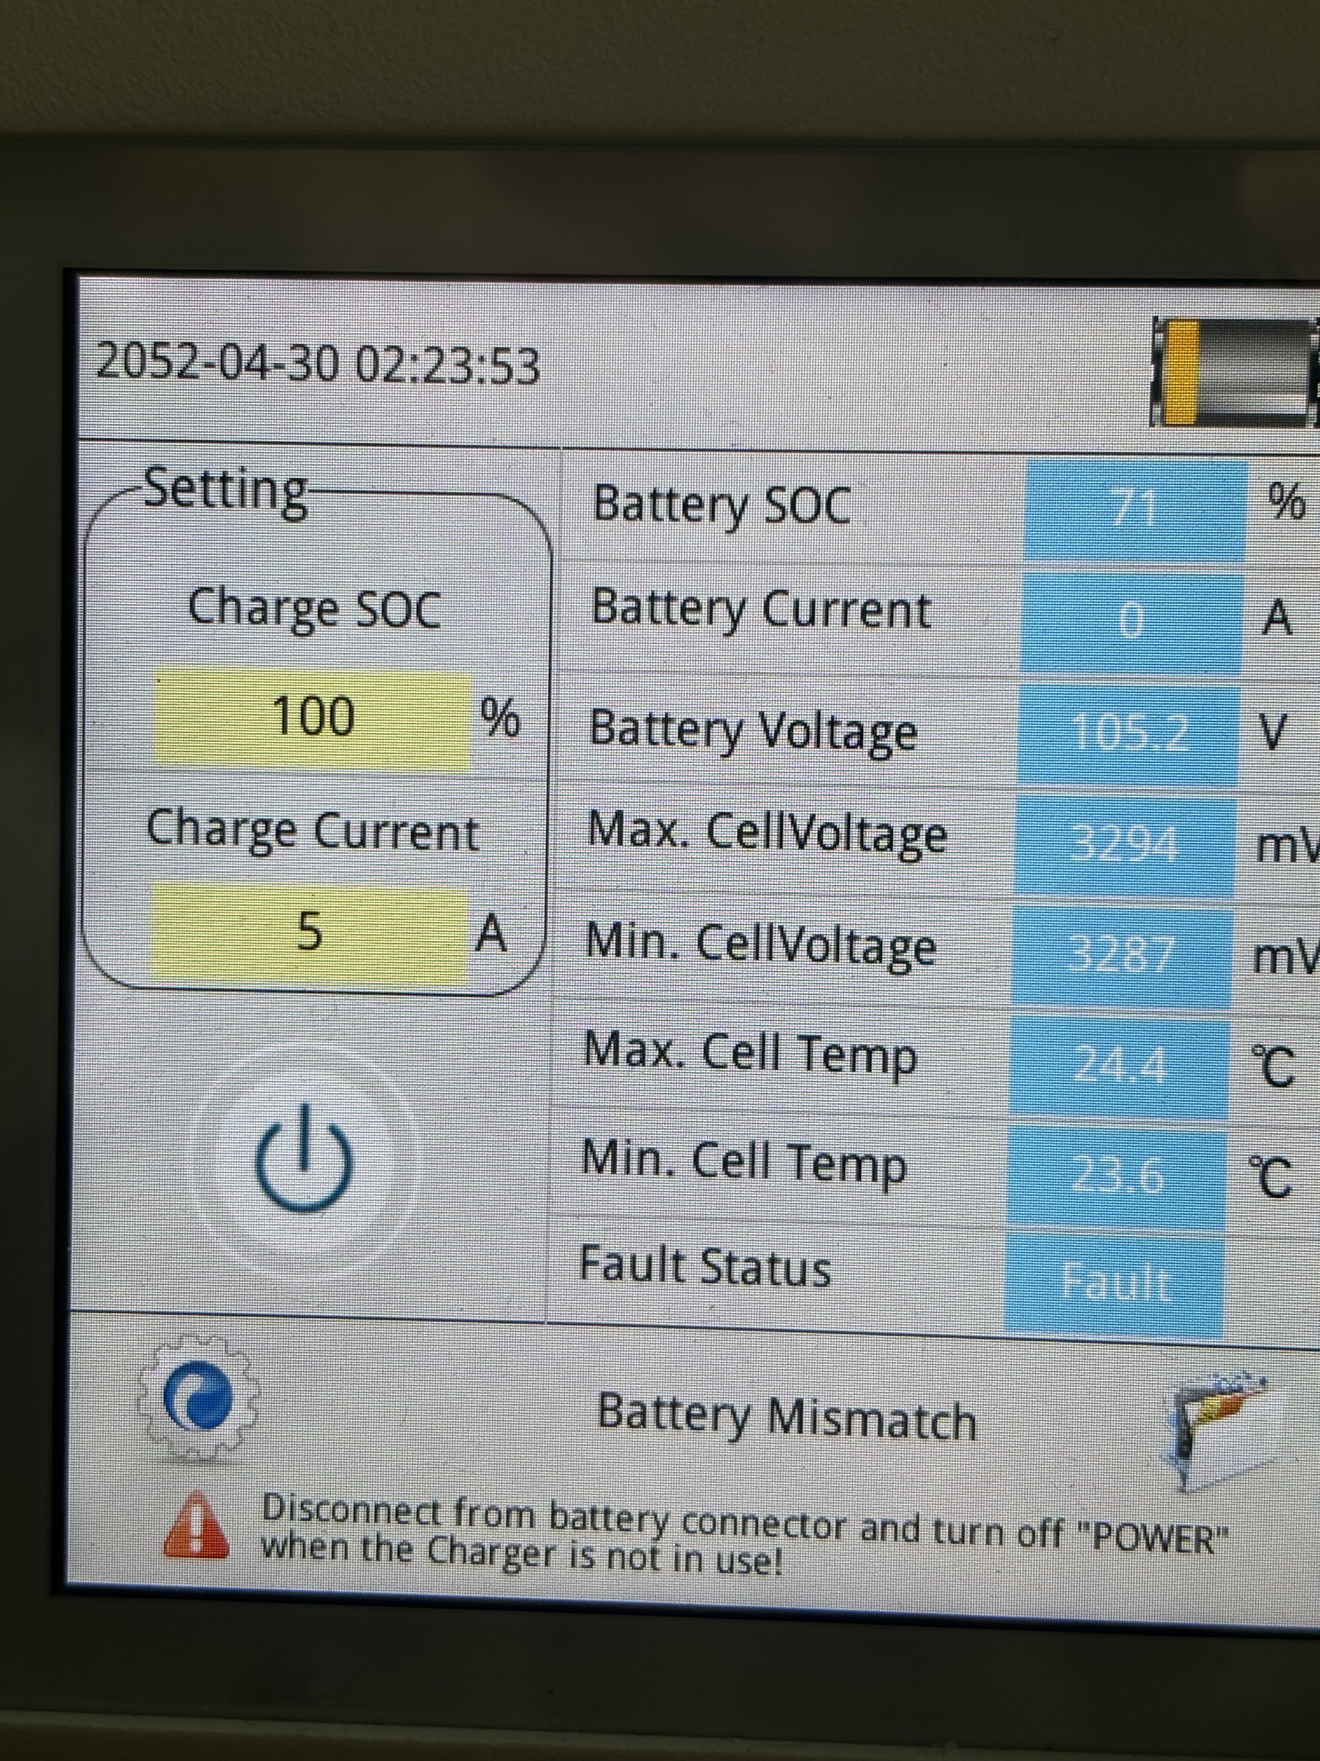
Confirmation of basic information
[Photo] SN number of batteries.
T-BAT-Charger can charge only one battery at a time.
Guidance for installer
Step1:Perform a black start on the batteries, and measure the voltage.Take the T58 and T30 batteries as examples.
T58 battery master | T30 battery with BMS
1)Set the DIP switch to position ‘4’  2)Turn on the system by moving the circuit breaker switch to the on position;  3) Press the button.  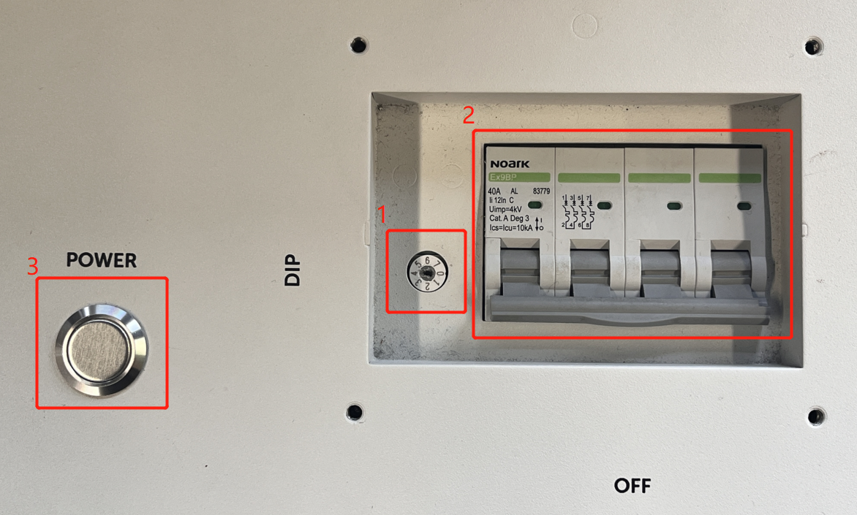  2  2  2  2 | 1)Move the circuit breaker switch to the on position to turn on the system;  2) Press the button and hold for 20 sec.  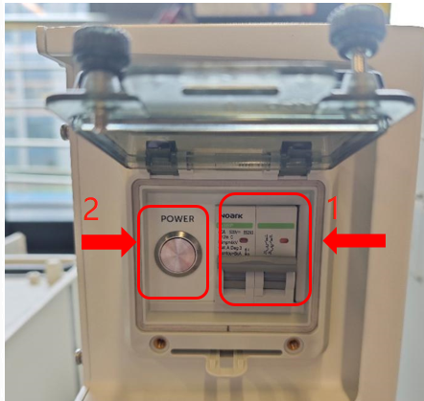  请在此放置您的文字

Step2:Measure the battery voltage.(For the T58 slave, a black start is not required; simply measure the voltage directly)
Measure the voltage of T58 | Measure the voltage of T30
Use the red pen and black pen of the multimeter to measure whether the voltage on the battery side is normal.  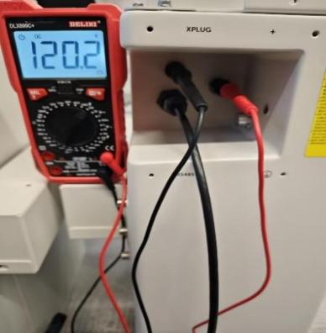 | Use the same method to measure the voltage of T30.  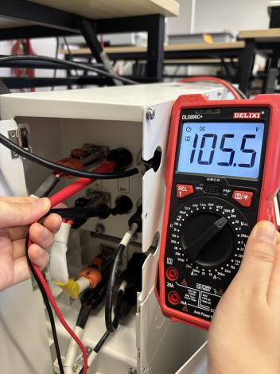
Tips:For the T58 battery, don't forget to connect the wiring on the Y-plug side during measurement.
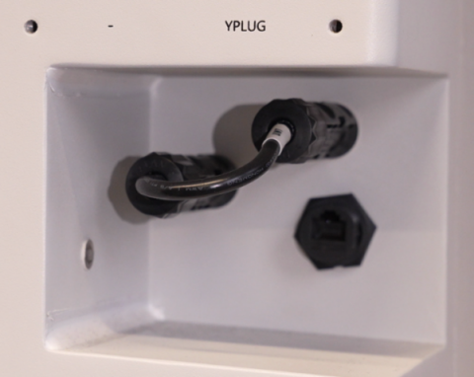
Step3:For the T58 battery, if the measurement result is 0V, directly contact the SolaX technical support team to have the battery replaced.
For the T30 battery, if the measurement result is 0, remove the BMS and directly measure the slave voltage.
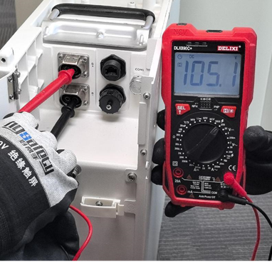
If the voltage measurement result is above 40V, the BMS is most likely damaged and should be replaced directly. If the measurement result is still 0V, it indicates that the battery is damaged and should be replaced.
Step4: Measure the voltage of the charger AC input power supply, ensure that the AC input voltage is within 180V-240V.
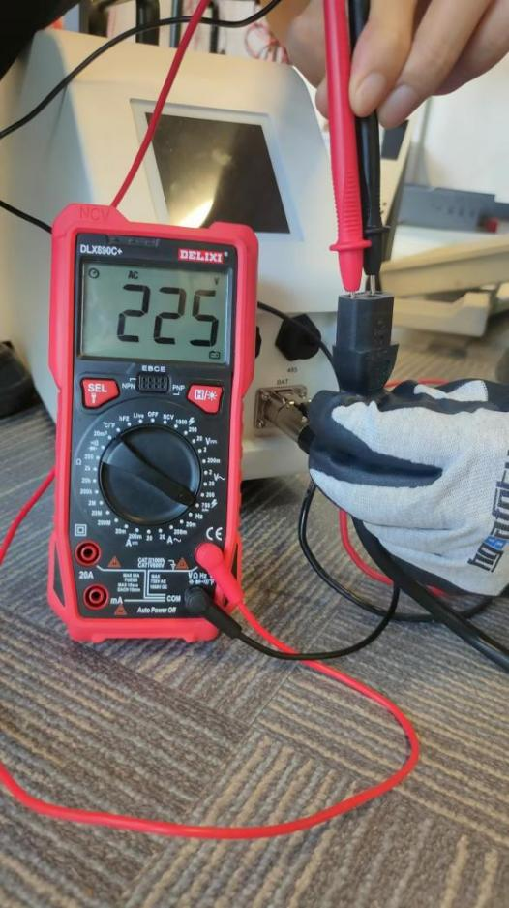
Step5: Disconnect power cable and communication between the battery and the charger. Turn on the charger and enable the forced charging function, then use multimeter to measure the voltage of the charger BAT port.
The setting path: setting →forced charging →password:860829→enable
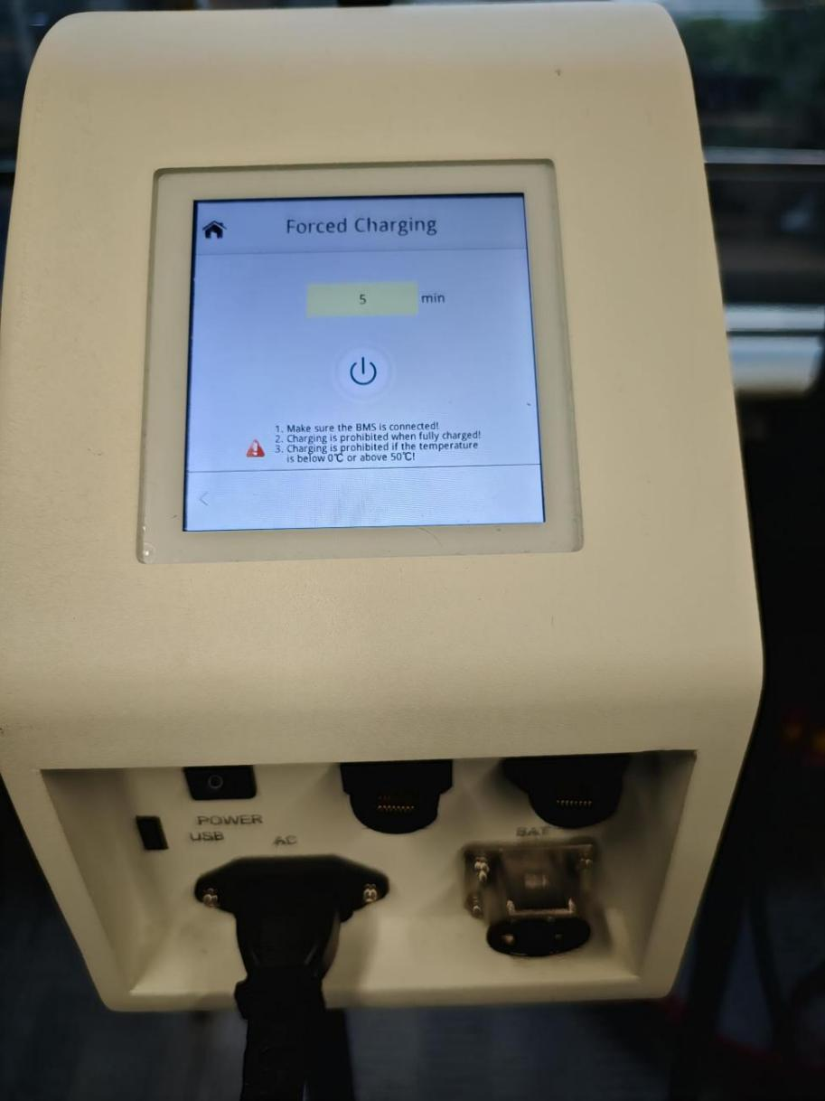
Use a multimeter to measure the DC voltage at the output port shown in the diagram below. A reading around 175V is normal.
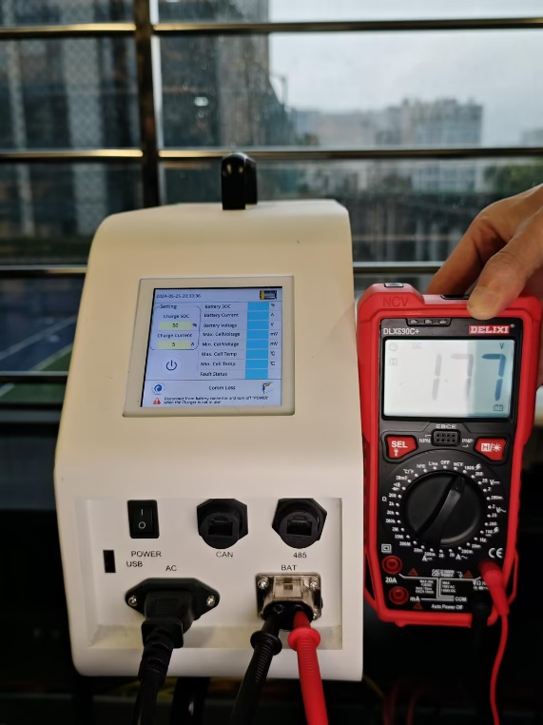
Step6: When the voltage of charger BAT port is normal, connect the power cable to the charger. At the end of the power cable, find the terminal for the battery that needs to be recharged, then measure the voltage of the two terminals. If there was no reading on the multimeter, replace the power cable and try again.
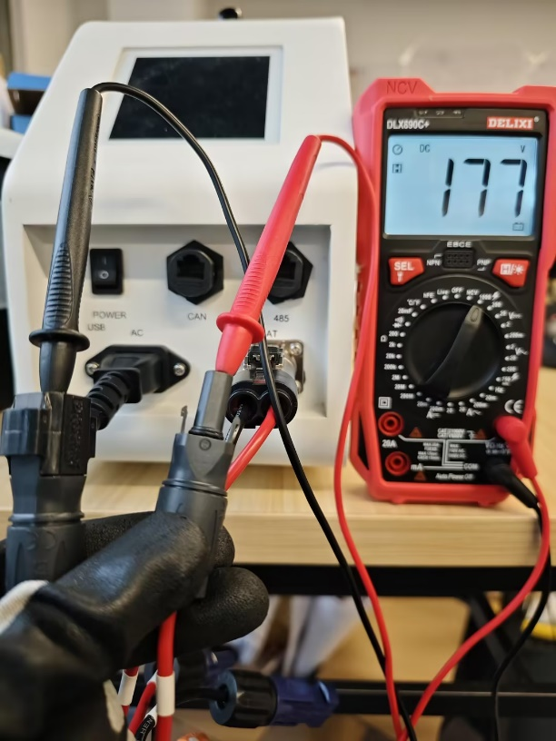
Step7:Upgrade the battery and the charger to the latest firmware version.
Information check list
If you have completed the above <Guidance for installer>, and the problem is still not solved, please collect the following troubleshooting information and send them to the R&D.
1.[Photo]SN number of batteries.
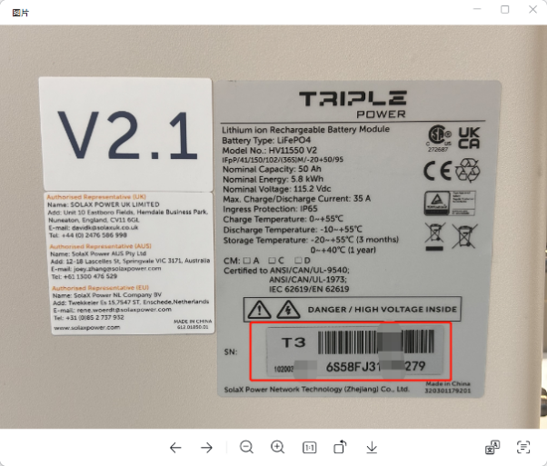
2.[Photo]The charger’s error report.

3.[Photo] Measure the voltage of the charger BAT port.

4.[Photo] Measure the voltage of the two terminals on the power cable.

- [Photo]The result of measuring the battery voltage.
Measure the voltage of T58 | Measure the voltage of T30
 | 

